

FAAC J275 2K20 HA BOLLARD
PROCUREMENT SPECIFICATION

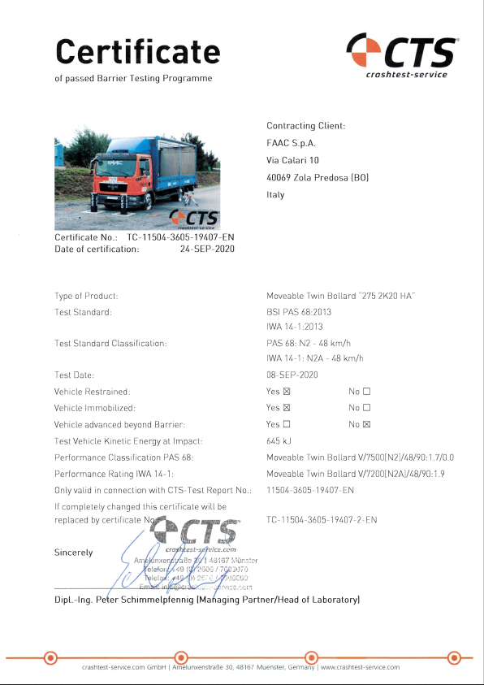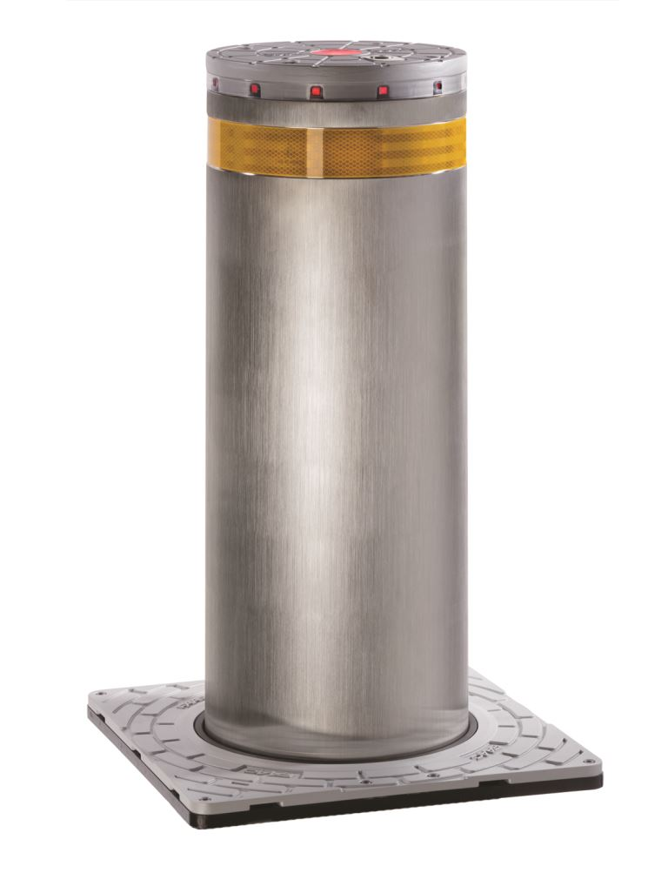

Hydraulic Automatic HIGH SECURITY BOLLARD FAAC J275 2K20 HA is crash tested in accordance to:
- PAS 68: Impact test specifications for vehicle security barrier systems
- IWA 14-1: Vehicle Security Barriers - Part 1: Performance requirement, vehicle impact test method and performance rating

APPLICATIONS:
Vehicular access control in critical areas, like: military sites, airports, embassies, consulates, banks, marine zones, prisons, industrial sites or wherever is required a high level of perimeter protection.

PRODUCT FEATURES:
FAAC J275 2K20 HA bollard is made of a reinforced steel support structure and a steel cylinder 800mm / 31.5 inches off ground, diameter 275mm / 10.8 inches available in S355JR EN 10219 steel, with polyester powder painted, or of stainless steel AISI 316L with satin finishing.
To prevent corrosion, the support structure and the cylinder –painted steel version- are treated with a surface cataphoretic coating, all the internal fastenings are realized in stainless steel and the bollard’s head is coated with special Rilsan® resin.
FAAC J275 2K20 HA bollard has to be allocated into the dedicated pit that sits within the reinforced concrete foundation realized according the civil work drawings.
The hydraulic unit (HPU) is integrated into the cylinder and accessible from above for maintenance and inspection with the bollard still in place. Ordinary maintenance operations do not require the usage of lifting machineries.
The cylinder is visible from all directions, thanks to the reflecting strip and the LED lights on the head that flash during the cylinder movement and stays permanently on while the cylinder is in upraised position. Each movement is signalled –and anticipated- by an acoustic buzzer.

PERFORMANCE:
FAAC J275 2K20 HA bollard is certified as capable to arrest vehicles of mass 7.500 kg / 16.535 pounds, driving at 50 kmh / 30 mph, corresponding to the performance ratings:
Performance rating:
PAS 68 PAS 68:2013 V/7500 (N2)/48/90:1.7/0.0
IWA 14-1 IWA 14–1:2013 V/7200 [N2A]/48/90:1.9

Bollard speed on normal duty:
Rising Time 8s / Lowering Time 4,5s
The above speed remains constant within the advised duty cycle.

HYDRAULIC UNIT:
The hydraulic unit (HPU) is allocated within the bollard’s cylinder; it comprises a 230VAC electric motor that operates a hydraulic pump.
In case of power failure, the upraised cylinder remains in position thanks to a mechanical lock.
To lower the cylinder it’s necessary to supply again the bollard, or operate the manual release under the cylinder’s head. The access to the manual release device is protected by an anti-burglar armoured lock (key supplied).
The hydraulic unit is supplied with a “Gentle Stop” function to slow down the movement in the last 30mm / 1.2 inches of the opening (lowering) movement, to reduce the mechanical stress and the noise generated by the cylinder’s descent.
The HPU protection index is IP67
AVAILABLE VERSIONS:
The cylinder finishing can be:
- Cataphoresis and polyester powder painted Dark grey metallized
- Stainless steel satin finishing

INSTALLATION COMPLEMENTS:
The bollard has to be placed into the dedicated pit, supplied with the cast iron counter frame.

CONTROL BOARD:
The control board for FAAC J275 2K20 HA bollard is a deported unit and manages up to 3 bollards. It’s supplied with 230VAC - 50/60Hz and includes several programmable –and customizable- logics to guarantee the desired operational routine.
A 16+1 poles cable (1.5mm2 / 0.002 inches2 min section) is required to connect the control board to the FAAC J275 2K20 HA bollard.

ACCESSORIES:
A pressure switch can be added to automatically reverse the upward movement in case an obstacle is hit while closing.
A solenoid valve can be added to automatically lower the bollard in case of power failure.
The accessories indicated above are not recommended for usages in security applications, as they subordinate the perimeter protection to the safe circulation of the vehicles

A Pit heater can be added, to operate also at extreme low temperatures (as below specified).

TECHNICAL SPECIFICATION:
Model | J275 2K20 HA | J275 2K20 HA STAINLESS STEEL
Drive | Hydraulic unit | Hydraulic unit
Cylinder height from ground | 800mm / 31.5 inches | 800mm / 31.5 inches
Cylinder diameter | 275mm / 10.8 inches | 275mm / 10.8 inches
Cylinder material | Steel S355JR EN 10219 | AISI 316L stainless steel
Cylinder treatment | Cataphoresis and polyester powder paint (Dark grey metallized RAL 7021) | Satin finishing
Cylinder’s head | Aluminium | Aluminium
Head treatment | Anti-corrosion Rilsan® resin | Anti-corrosion Rilsan® resin
Ground cover material | Aluminium | Aluminium
Ground cover treatment | Anti-corrosion Rilsan® resin | Anti-corrosion Rilsan® resin
Rising time | ~8 s | ~8 s
Lowering time | ~4,5 s | ~4,5 s
Emergency automatic lowering | YES (OPTIONAL) | YES (OPTIONAL)
Emergency lowering time | ~2 | ~2
Obstacle detection while rising | YES (OPTIONAL) | YES (OPTIONAL)
Emergency manual lowering | Accessible with supplied key | Accessible with supplied key
Gentle Stop function | YES | YES
Power supply | 207 V~ ... 243 V~ - 50/60 Hz | 207 V~ ... 243 V~ - 50/60 Hz
Max consumption | 575 W | 575 W
Protection index | IP67 | IP67
Load class(EN 124) | C250 | C250
Break-in resistance  (2 units configuration) | 673.000 J | 673.000 J
Operating temperature | -15°C / +55°C | -15°C / +55°C
Operating temperature with heater (accessory) | -25°C / +55°C | -25°C / +55°C
Bollard weigth | 170 kg // 375 pounds | 170 kg // 375 pounds
Bollard packagind dimensions LxWxH | 1.200 mm x 800 mm x 450 mm //  47 inches x 31 inches x 18 inches | 1.200 mm x 800 mm x 450 mm //  47 inches x 31 inches x 18 inches

PIT:
Dimensions LxWxH | 550 mm x 619 mm x 1245 mm // 22 inches x 24 inches x 49 inches
Material | Steel EN 10346-DX53+Z140-A: thickness 2mm / 0,08 inches
Counterframe | Ductile casted iron, treated with cataphoresis
Pit weight | 80 kg // 176 pounds
Pit packaging LxWxH | 800 mm x 600 mm x 700 mm // 31 inches x 24 inches x 28 inches

FOUNDATION:
Dimensions LxWxH  (2 units configuration) | 2.400 mm x 3.100 mm x 1.540 mm // 95 inches x 122 inches x 61 inches
Concrete Specifications: | Class C25/30 Concrete with 10-30 aggregate according to UNI EN 12620 standard. Bollard shall be installed after at least 7 days of concrete setting; using a proper additive, it’s possible to reduce to 3 days
Surrounding ground compacting index | ≥ 90% of the Proctor optimum curve, according to UNI EN 13286-2:2005 standard

