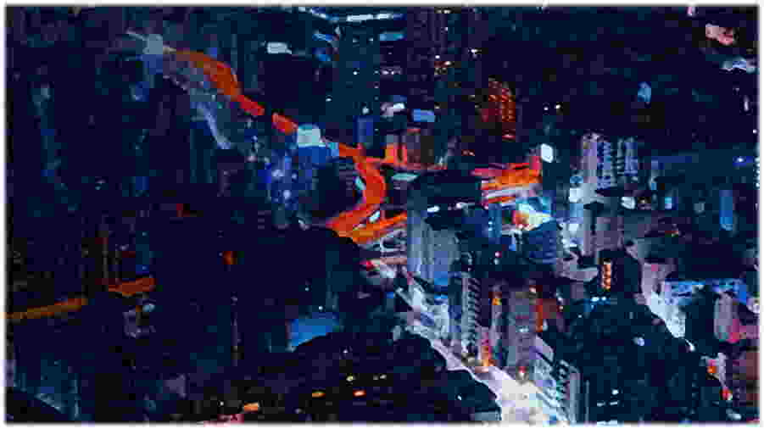

FAAC SECURITY BOLLARD J275 2K20 F
PROCUREMENT SPECIFICATION

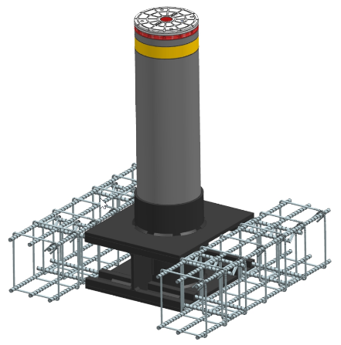
Static shallow mounted perimeter protection bollard J275 2K20 F.

APPLICATIONS:
Delimitation and protection of perimeter of critical areas like: military sites, airports, embassies, consulates, banks, marine zones, prisons, sensitive industrial sites or wherever high security is required.

PRODUCT FEATURES:
J275 2K20 F bollard comprises a cylinder with height 800mm / 31.5 inches off ground, diameter 275mm / 10.8 inches, made of S355JR EN 10219 steel, with surface treatment anti-corrosive in cataphoresis and polyester powder painted, or stainless steel AISI 316L satin finishing.
To prevent corrosion, the bollard’s head is coated with special Rilsan® resin.
The bollard has to be placed in a shallow foundation –Shallow Mounted concept- realized as described in the installation manual, reinforced by employing ≥Ø12 mm / 0.5 inches Class B450C iron bars, in compliance with ASTM A615 - Grade 60 and then filled with Class C25/30 concrete 10-30 (UNI EN 12620)
To guarantee the nominal resistance of the bollard, the cylinder has to be filled with the same type of concrete.

This Bollard is designed to stop a vehicle weighing 6800 kg / 15000 pounds, running at 50Kmh / 30mph and having capability to adsorb at least an energy of 656000J in accordance to ASTM F2656M standard.
The above performance are obtained in installations realised as described in the supplied manual.

Cylinder above ground is visible on all environment conditions, having a 55mm / 2.2 inches high reflecting strip all around the cylinder itself, and LED lights –power unit not supplied-.

OPTIONS:
The cylinder finishing can be:
- Cataphoresis and polyester powder painted Dark grey metallized
- Stainless steel satin finishing

J Series Model | J275 2K20 F | J275 2K20 F ST.STEEL
Cylinder height from ground | 800 mm / 31.5 inches | 800 mm / 31.5 inches
Cylinder diameter | 275 mm / 10.8 inches | 275 mm / 10.8 inches
Cylinder material | Steel S355JR EN 10219 | AISI 316L satin stainless
Cylinder surface | Cataphoresis and polyester powder painted  Dark grey metall. RAL 7021 | AISI 316L satin stainless steel jacket
Head | Aluminium RAL 9006 | Aluminium RAL 9006
Head treatment | Anti-corrosion Rilsan® resin | Anti-corrosion Rilsan® resin
Reflective strip height | 55 mm / 2.2 inches | 55 mm / 2.2 inches
Reflective strip colour | Yellow | Yellow
Break in resistance [J] | 656000 | 656000
Total weight | 110 kg / 242.5 pounds | 110 kg / 242.5 pounds
Underground product dimensions WxDxH | 450 x 450 x 55 mm  17.5 x 17.5 x 2.2 inches | 450 x 450 x 55 mm  17.5 x 17.5 x 2.2 inches
Required excavation dimensions WxDxH | 4.410 x 2.500 x 270 mm  14.5 x 8.2 x 0.9 feet * | 4.410 x 2.500 x 270 mm  14.5 x 8.2 x 0.9 feet *
TECHNICAL SPECIFICATIONS

* add 10mm / 0.4 inches above the foundation to lay the pavement and 10mm / 0.4 inches below for the base of mud slab

